Monoblock with two types of valve
for tight installation situations

Klingenberg, March 2020.- The new model IBM monoblock from WIKA is designed to be space-saving and robust. The compact instrumentation valve is optionally available with threaded connections angled at 90°, ball valves and/or needle valves.

Due to its properties and dimensions, the new model IBM monoblock is particularly suitable for protecting measuring instruments in wellhead control panels and sampling systems for process analysis. The model IBM can be designed for operating pressures up to 10,000 psi (690 bar). Even with such a load, the manufactured quality of the valve enables smooth handling with low torque. Versions with ball valves also offer a redundant polymere-metal sealing system with tested tightness in accordance with BS6755 / ISO 5208, leakage rate A. Depending on the application, the new monoblock can be configured with the valve arrangements of double block & bleed or block & bleed.

The model IBM primarily fulfils an upstream protective function, either separately in the pipeline or at the end of a “hook-up”. WIKA offers such assembly of measuring instruments and protective components on a customer-specific basis. It is delivered ready-to-use and leak tested.

Number of characters: 1.167
Key word: Monoblock IBM

Manufacturer:
WIKA Alexander Wiegand SE & Co. KG
Alexander-Wiegand-Straße 30
63911 Klingenberg/Germany
Tel. +49 9372 132-5049
Fax +49 9372 132-406
vertrieb@wika.com
www.wika.de

WIKA company photograph:
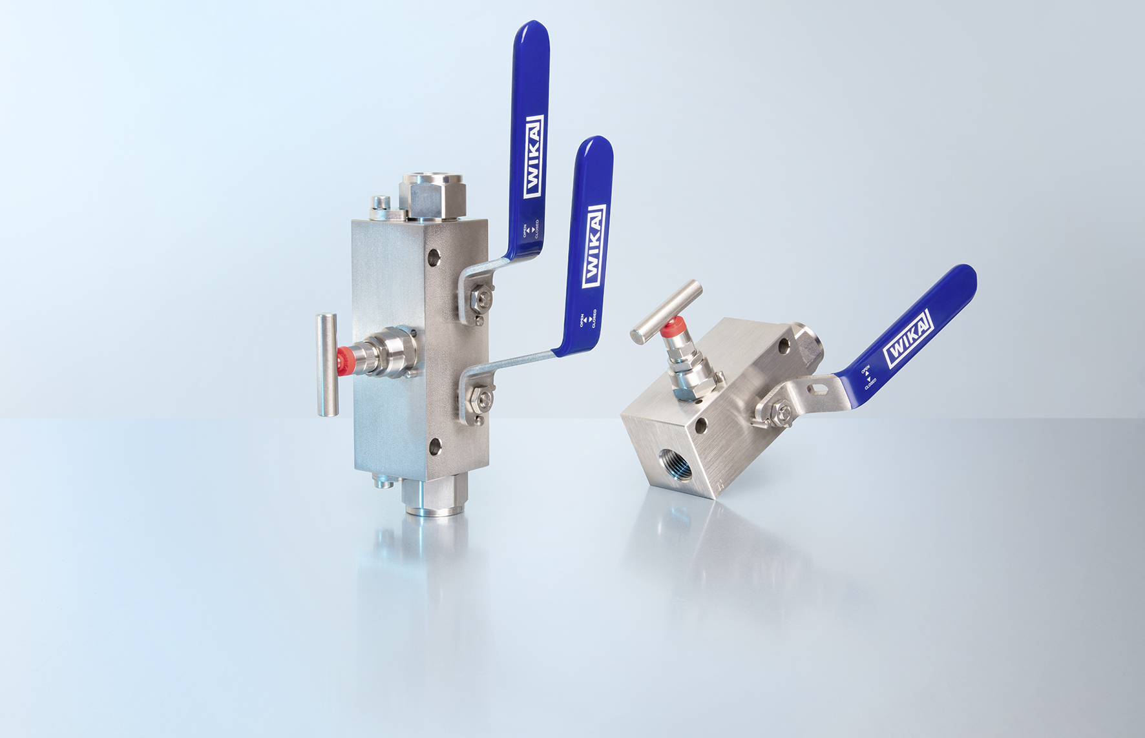
IBM monoblock

Edited by:
WIKA Alexander Wiegand SE & Co. KG
André Habel Nunes
Marketing Services
Alexander-Wiegand-Straße 30
63911 Klingenberg/Germany
Tel. +49 9372 132-8010
andre.habel-nunes@wika.com
www.wika.de

WIKA press release

